**Setting up the Batch File**

Step 1: Getting your network name

1. Hover over the network icon in your taskbar, click on the icon  
   
2. The name above “Secured/Connected, secured” is your network name

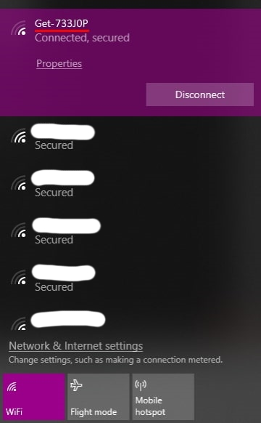

Step 2: Editing the batch (.bat) file

1. Open “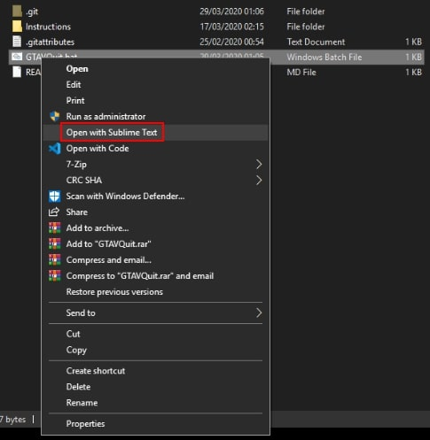GTAVQuit.bat” with a text editor (Notepad, Notepad++, Sublime etc…)
2. On line 10, replace **** after “**name**=” with your network name.  
   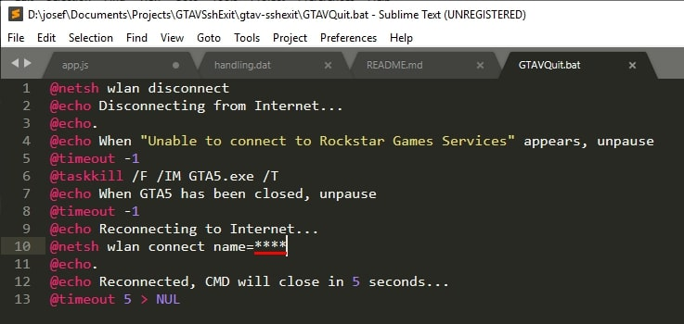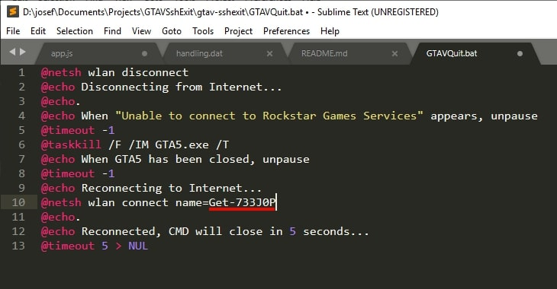
3. Press **Ctrl + S** to save the file.  
   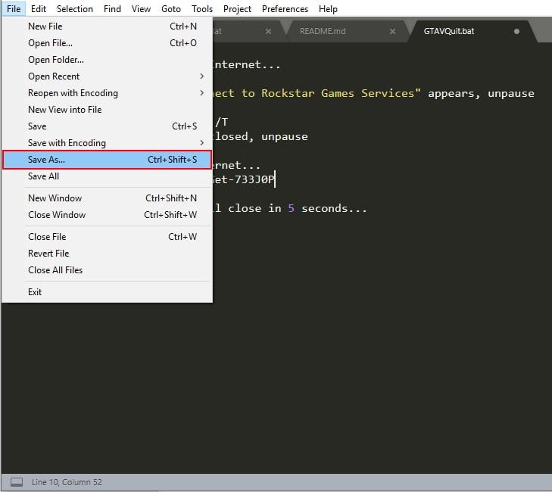

Step 3: Test in-game

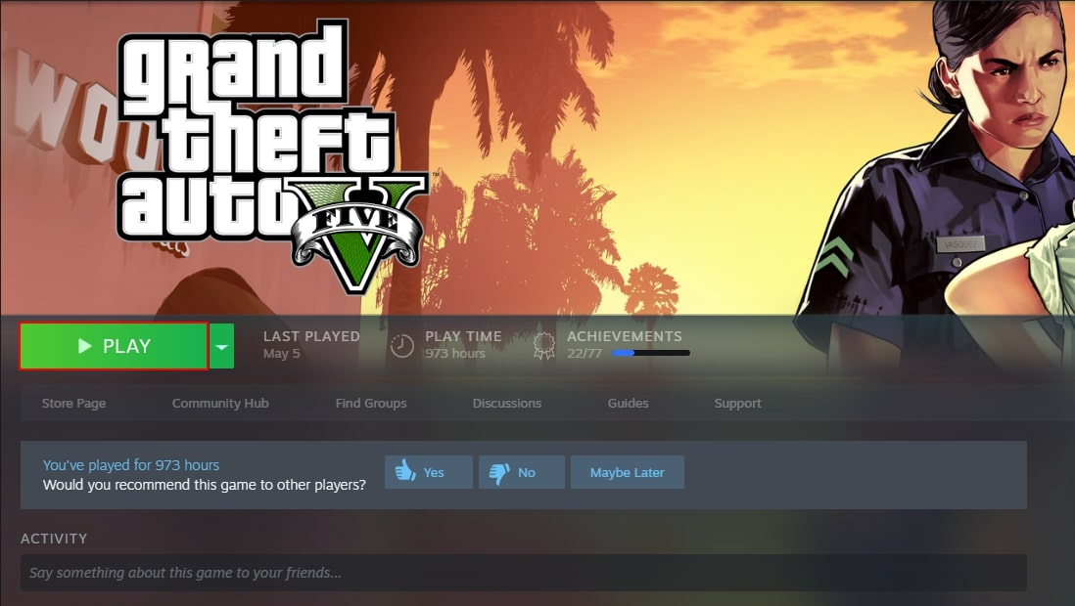

Head into GTA online and run this script.

If you typed the correct **name** value into the batch file you will reconnect (after disconnecting) to your network at the end of the script.